Yerevan AgentPark– Armenia’s Next Frontier in Artificial Intelligence
The Yerevan AgentPark is set to become the beating heart of Armenia’s growing AI ecosystem — a future-focused hub that brings together innovation, entrepreneurship, and education.The AgentPark team is composed of experienced professionals who have been actively involved in the development of Armenia’s technological ecosystem, including work on the creation of high-tech clusters within the USAID CAPS program.

Powered by Global Momentum: NVIDIA based AI Factory
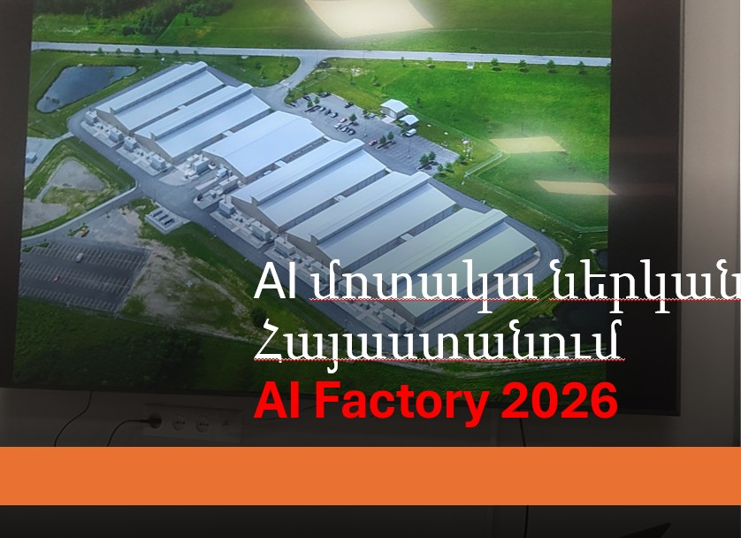
A major milestone in Armenia’s technological rise will be the 2026 launch of NVIDIA’s AI factory, which will serve as a transformative boost to the entire ecosystem. As a globally recognized leader in AI hardware and computing, AI Factory presence will attract international attention, inject high-performance computing capacity, and position Yerevan as a regional tech hub.

🚀 A Launchpad for Innovation
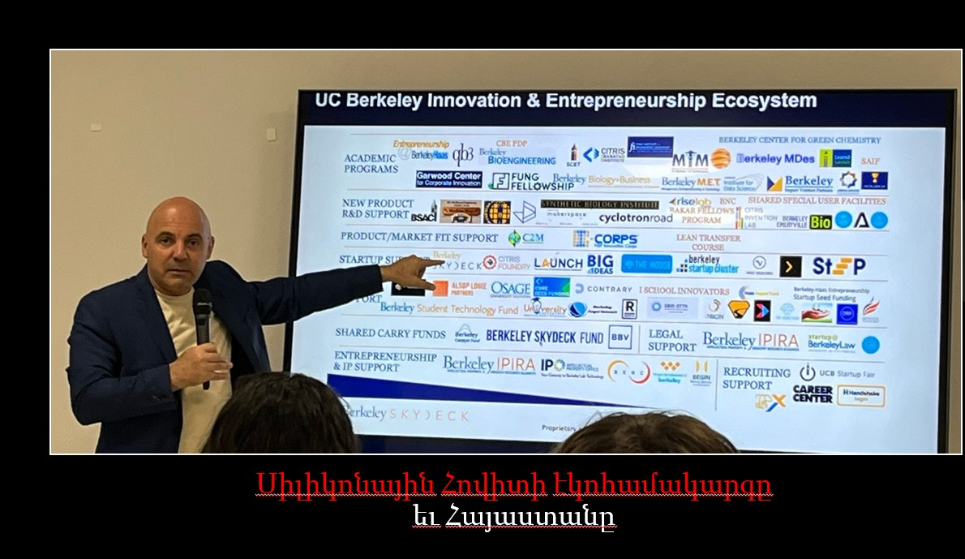
Yerevan AgentPark will function as both an AI accelerator and incubator, nurturing local startups with strategic support in technology, business development, and consulting. Backed by financial investment and an experienced leadership team, the Park will elevate Armenian innovation to the global stage.

🧠 A Knowledge and Talent Magnet
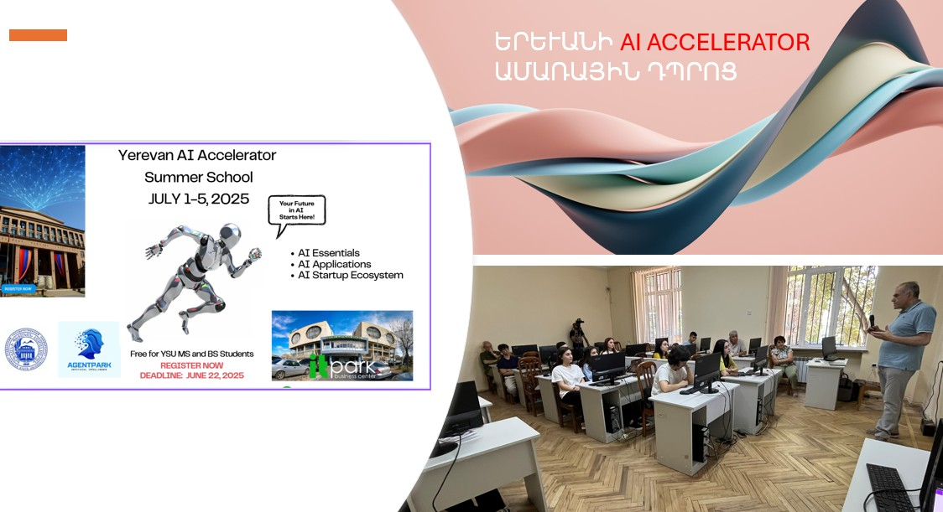

With strong ties already forged with Armenia’s leading universities, such as the Faculty of Applied Mathematics at Yerevan State University, the Park hosted its first AI Summer School in July, 2025. Ongoing collaborations with academic institutions ensure that young talent will find a home for growth, experimentation, and learning.

🌍 A Cross-Sector Platform
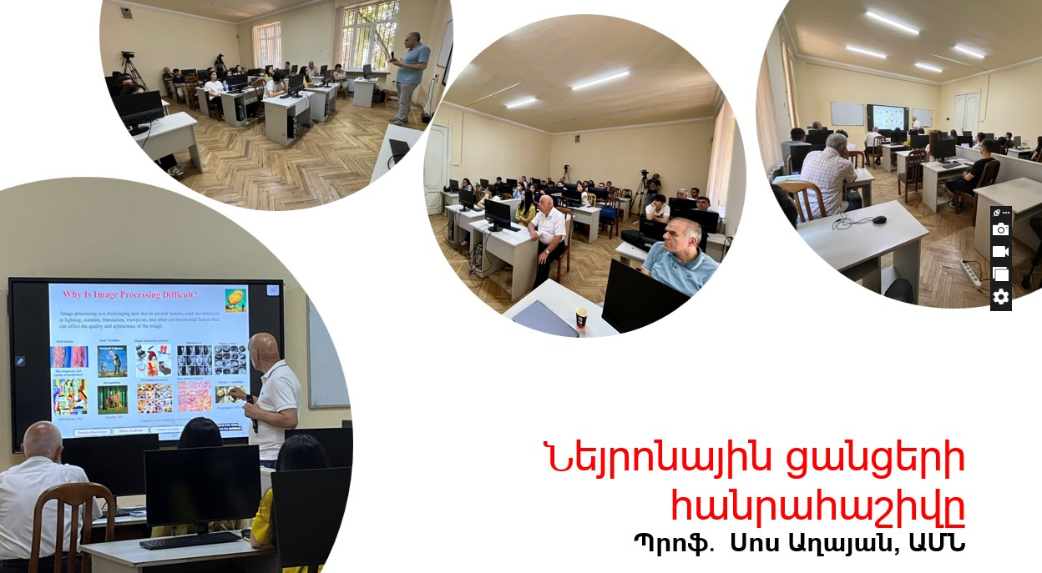
Beyond technology, the Park will be building bridges across sectors — integrating healthcare, agriculture, design, and cultural institutions into its innovation framework. It aims to become a platform for cross-disciplinary projects, making AI more accessible and relevant to everyday challenges.

🎨 A Cultural and Creative Nexus
AgentParkis more than a tech hub — it's also envisioned as a platform for art and design, where creative minds collaborate with technical experts to redefine the boundaries of expression, interaction, and intelligence.

🧩 Building Community Connections

The Park will serve as a community space, inviting local residents and students to participate in AI-related events and educational programs. By bridging the gap between seasoned professionals and young enthusiasts, it aims to foster a culture of mentorship and mutual learning.

🌍 Global Events, Local Impact
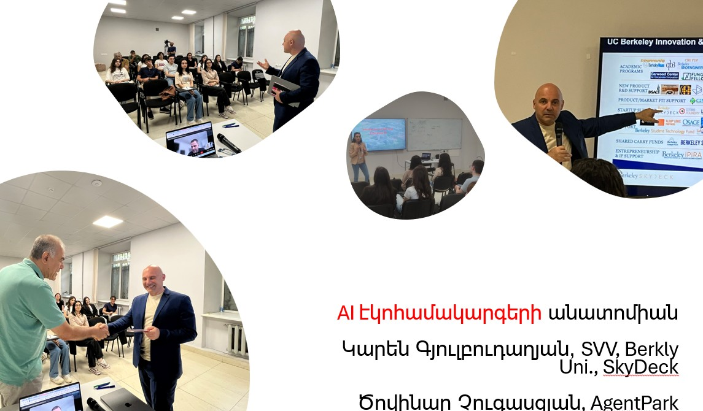
Regular international conferences and hackathons will bring together leading minds from Armenia and abroad, turning Yerevan AgentPar kinto a regional hub for innovation and dialogue. These events will spark new ideas, partnerships, and research, strengthening Armenia’s position on the global tech map.

Yerevan AgentParkis not just a building — it’s the birthplace of Armenia’s AI future.
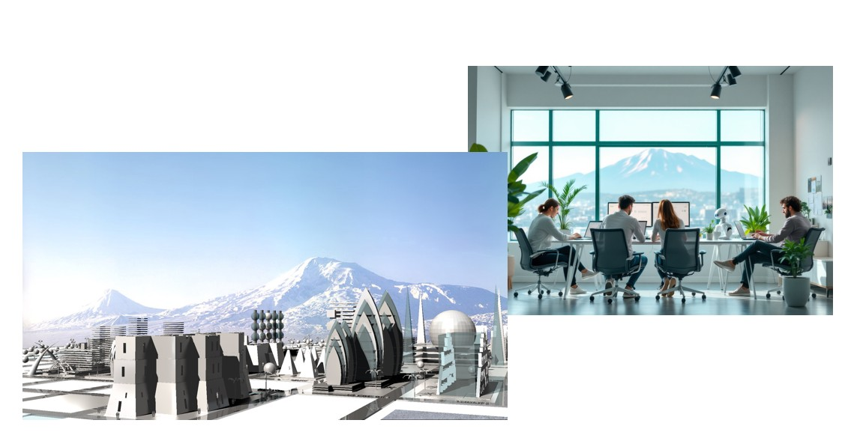

It’s where startups scale, communities connect, and ideas become impact.

